READ ME

GROUP: NEWBIES

‘Home Online Tutor’

|  |  |
| --- | --- |
| **NAME** | **MATRIC NO.** |
| 1. WAN MUHAMMAD IZZAT BIN WAN ABD GHAPAR | 1816343 |
| 1. MUHAMMAD HUSIN BIN AHMAD RUMAIZI | 1813165 |
| 1. MUHAMMAD AZRUL BIN NOOR AZMI | 1811839 |
| 1. TENGKU NUR IZZAH ATIRAH TENGKU MAHAMUD | 1822438 |
| 1. SITI NOR AFIQAH BT MAT HASSAN | 1829714 |

‘Home Online Tutor’ is a website for students who want to search for a private tutor from the available nearby location around Malaysia.

**1. Group Contributions**

This website, Home Online Tutor, needs several web pages to complete the full website. The pages that we include are Front page, The subject and their level which are UPSR, PT3 and SPM, Register and login, About us and contact and Payment. In the front page, the user directly can choose whether they are the student and tutor. As we have 5 members so easy for us to divide the page. However as a group, we will help each other if someone needs help.

For the final part, we added javascript functionality to all our pages to enhance the behavior of the website. APIs like google maps API are also used to create an interactive map instead of static map. JQuery is also being used to simplify a lot of javascript code to be less complicated. We also use Ajax to fetch fake data from level.json and bank.json to check available level and verify the bank account.

Table 1 Group Contribution

|  |  |
| --- | --- |
| **Name** | **Contribution** |
| Izzat | * Pages: The Front page for choosing either a tutor or a student and check which level available from data (level.json) * Web Elements: Images, responsive tiles, Bootstrap (Modal, row, column), Ajax, json |
| Afiqah | * Pages: The subject and their level which are UPSR, PT3 and SPM. * Web Elements: Image, responsive tiles, . |
| Azrul | * Pages: About us, Contact us/Inquiry form and Javascript functionality on Sign Up page. * Web Elements: Image, Form Box, checkbox, Google Maps API, JQuery, Form Validation |
| Husin | * Pages: Registration and login page. * Web Elements: Radio box, checkbox * Javascript: add validation to the login page (username and password) |
| Izzah | * Pages : Payment and Detail message after make the payment * Web element : Form Box , option select button, select button, image, JQuery, bootstrap, link,Ajax,json |

**3. Use of third party resources**

Graphics: All team members obtained all graphics for the Catalogues from pexels.com, a website for high quality stock photos.

Form Builder: Team members Azrul uses the form builder to create a form in the contact us page. Modifications are documented in Table 2.

Google Maps: Team member Azrul uses Google Maps API to show the Headquarter of our company however the API needs to be billed. Thus, we just showed the non-interactive map.

Javascript Library: Team member Azrul uses javascript library at JavaScripting.com for the functionality in the sign up page such as check password strength and confirmation of the password.

|  |  |  |
| --- | --- | --- |
| **Web Elements** | **Team Members** | **Modifications** |
| Graphics | * Azrul * Husin * Izzat * Izzah * Afiqah | All graphics are resized using CSS and HTML. |
| Form Builder | * Azrul * Husin * Izzat * Izzah * Afiqah | Form created using the form builder to restyle to the main page. |
| Fonts | * Azrul * Husin * Izzat * Izzah * Afiqah | Use same fonts to make our website consistent and no fibers |
| Google Maps | * Azrul | Uses a certain latitude and longitude for the location and resized the API using CSS. |
| Javascript Library | * Azrul * Izzah | Redo the codes to match up the attributes and values for the pages. |
| JQuery | * Izzah | To create Event.preventDefault |
| Bootstrap | * Izzat | To show Modal |

**References**

Negative Space. Pexels. Retrieved 25 June 2020 from <https://www.pexels.com/photo/iphone-notebook-pen-working-34088/>

fauxels. Pexels. Retrieved 25 June 2020 from <https://www.pexels.com/photo/top-view-photo-of-people-near-wooden-table-3183150/>

JavaScripting.com - The Database of JavaScript Libraries. Javascripting.com. (2020). Retrieved 9 August 2020, from <https://www.javascripting.com/>

Overview | Maps JavaScript API | Google Developers. (2020). Retrieved August 9, 2020, from Google Developers website:

<https://developers.google.com/maps/documentation/javascript/overview/>

Javascript Form - Javascript Form Validation (2020).

Retrieved August 9,2010, from <https://www.w3schools.com/js/js_validation.asp>

Validation - Bootstrap Form Validation (2020).

Retrieved August 8,2020, from

<https://mdbootstrap.com/docs/jquery/forms/validation/>

‌

‌

**APPENDIX**

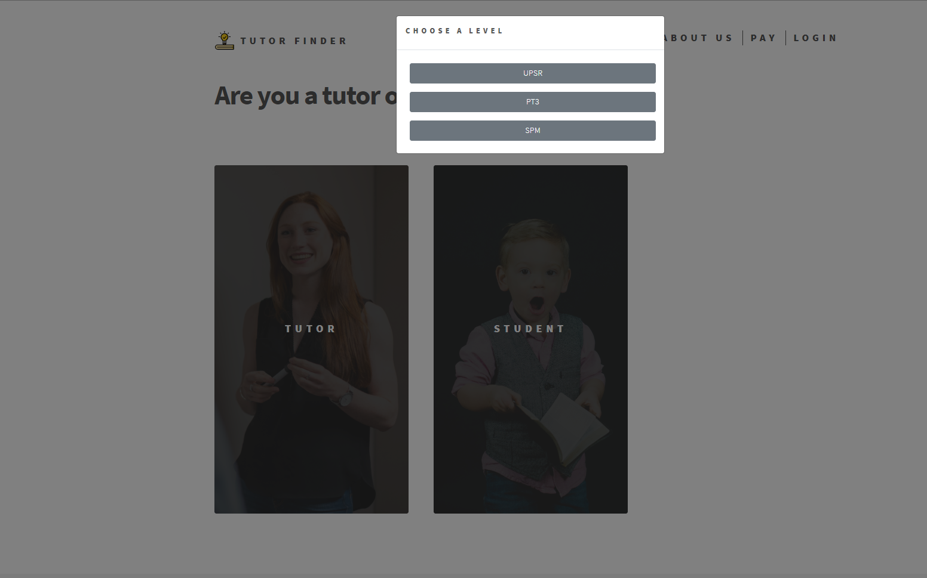

Figure 1: Main page after clicking student

Figure 2 : The page for student choose the subject

Figure 3: About us page

Figure 4: Location Map using Google Map API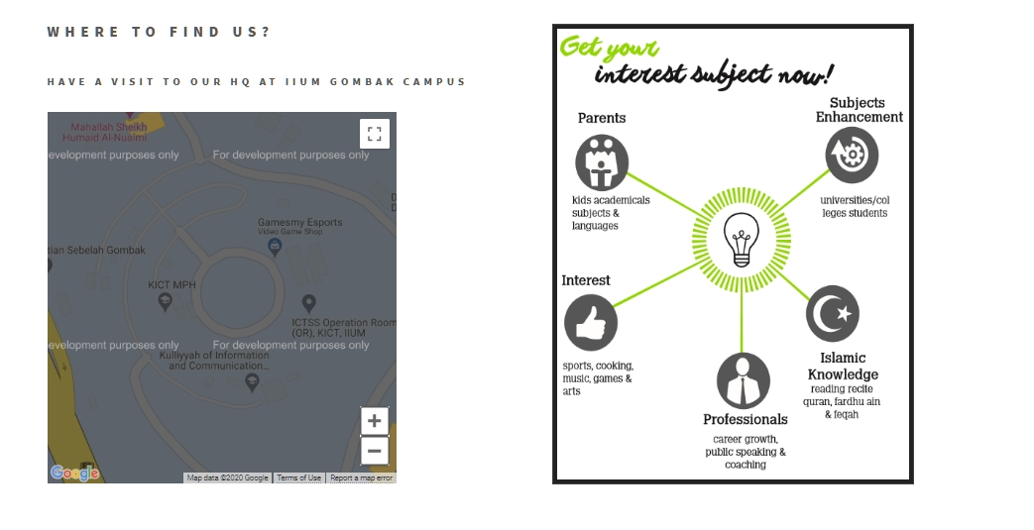

Figure 5: Contact Us footer segment(all pages)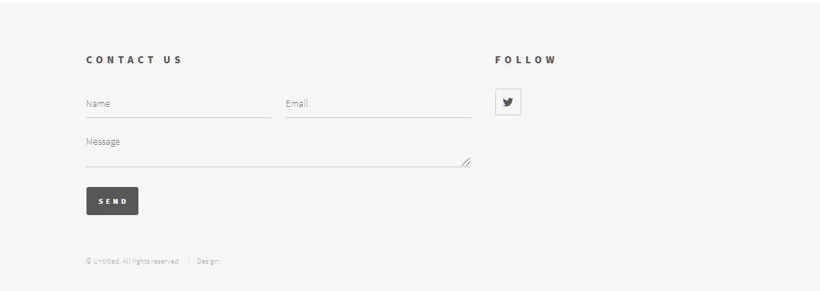

Figure 6 : Message detail will appear after clicking the submit button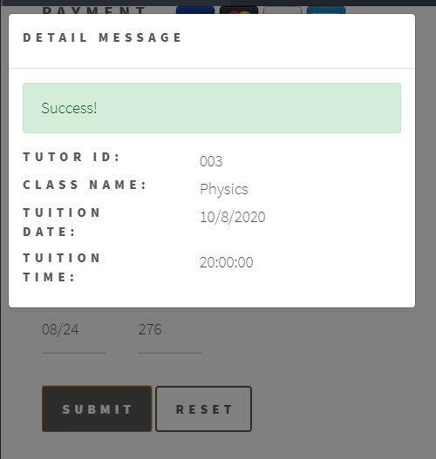

Figure 7: Payment page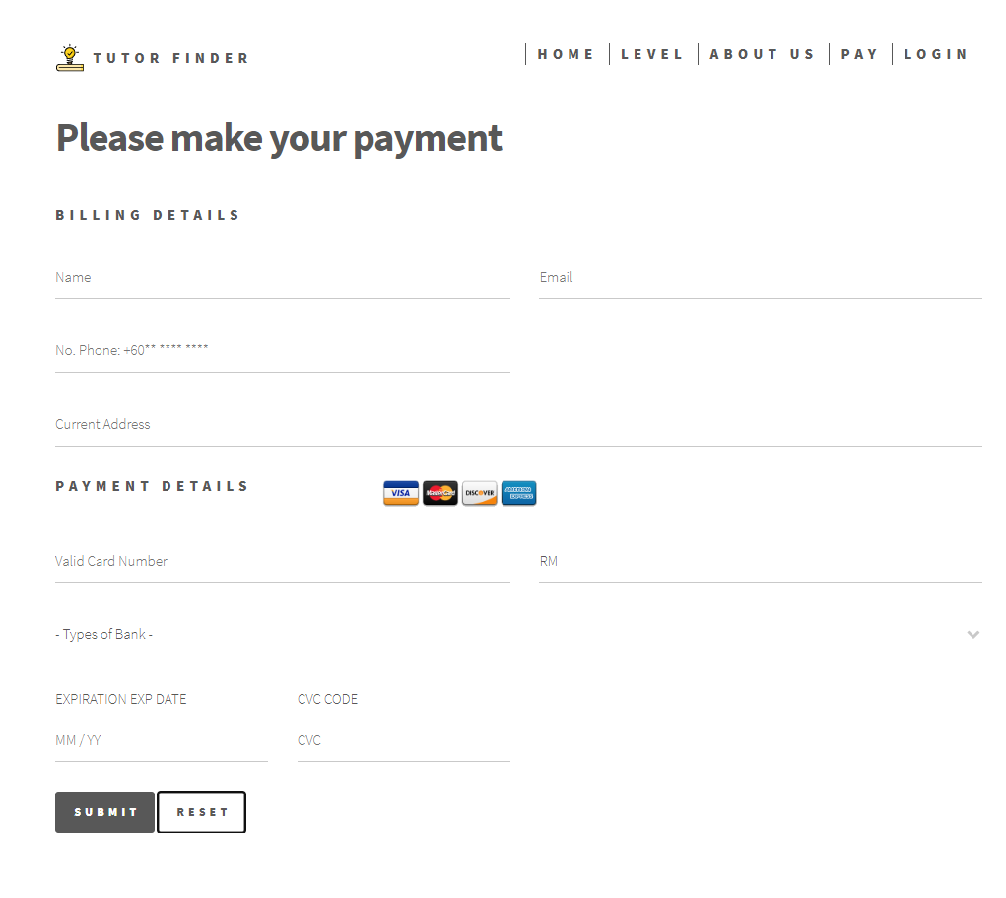

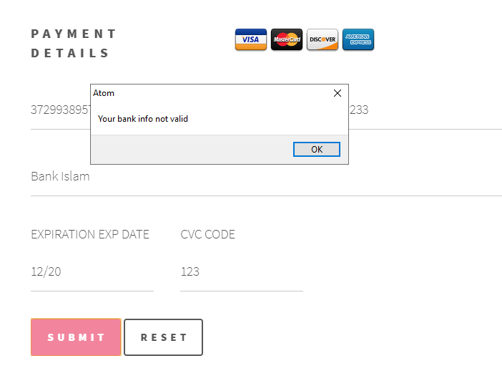

Figure 8 : Payment page after adding javascript

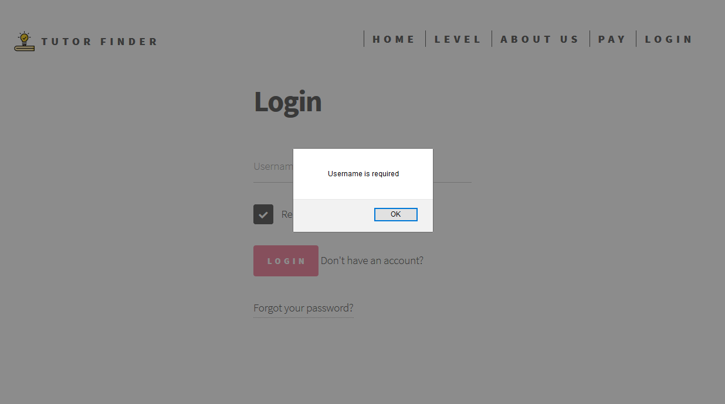

Figure 9: Login Page with added javascript

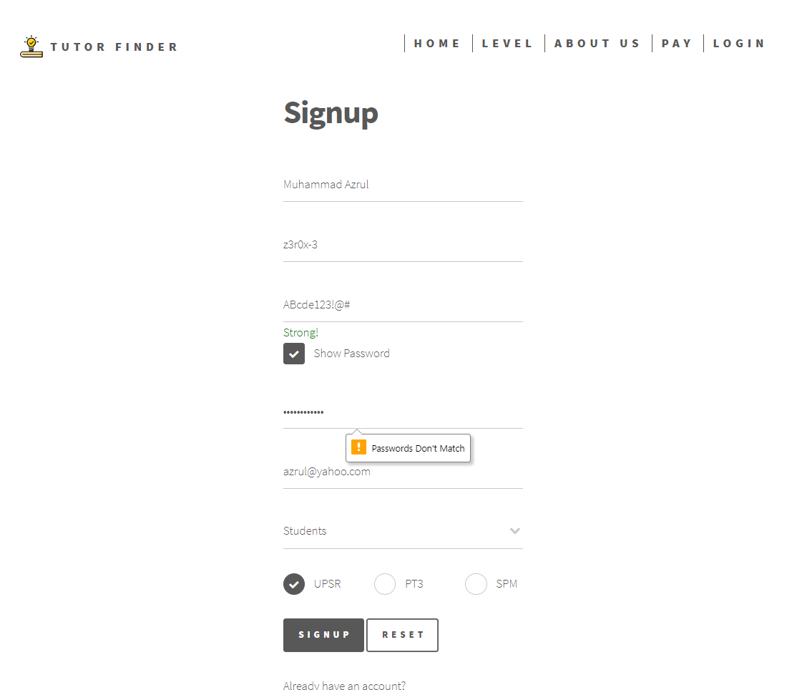

Figure 10: Sign up page with added javascript